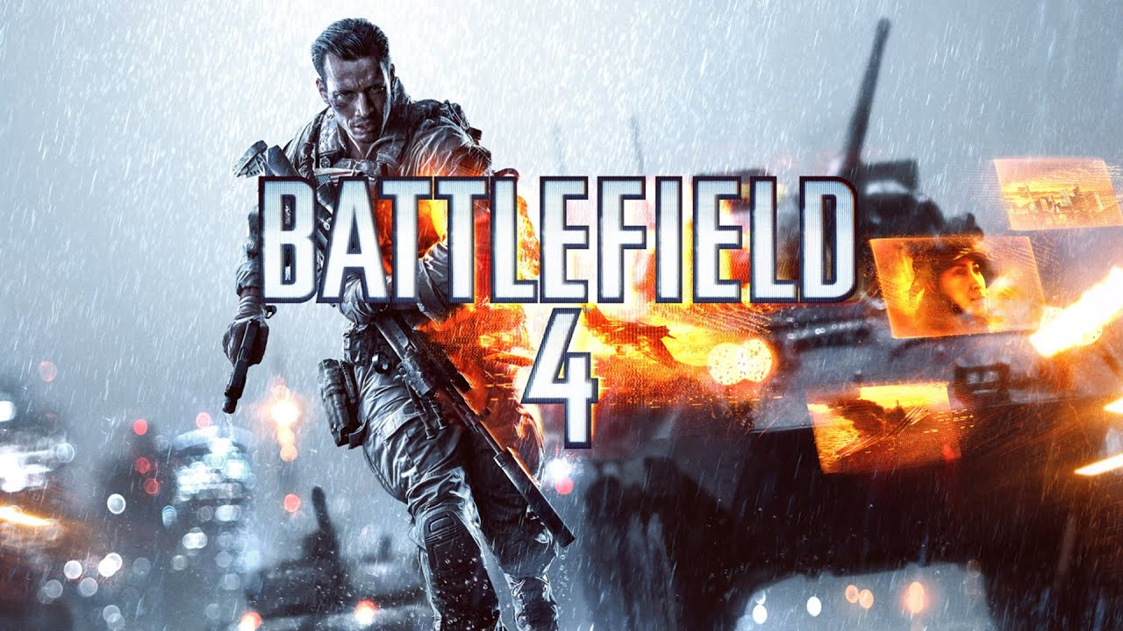

**BATTLEFIELD 4**

**Developed By:**[DICE](https://www.google.com/search?sxsrf=AOaemvKadG7I4oQKQlzgP_pPikOIe05g9g:1640621791254&q=EA+DICE&stick=H4sIAAAAAAAAAOPgE-LSz9U3KCrIyDVIU-IEsY3STcuMtFSyk630k8vS9ZPzcwtKS1KL4ssyU1Lz0xNzU61SUstSc_ILUosWsbK7Oiq4eDq77mBlBACUYwhQTAAAAA&sa=X&ved=2ahUKEwij1s-4sIT1AhUISvEDHfofDNsQmxMoAXoECEUQAw&cshid=1640621936706097), [Ripple Effect Studios](https://www.google.com/search?sxsrf=AOaemvKadG7I4oQKQlzgP_pPikOIe05g9g:1640621791254&q=Ripple+Effect+Studios&stick=H4sIAAAAAAAAAOPgE-LSz9U3KCrIyDVIUwKzK0uMi1MstFSyk630k8vS9ZPzcwtKS1KL4ssyU1Lz0xNzU61SUstSc_ILUosWsYoGZRYU5KQquKalpSaXKASXlKZk5hfvYGUEANfnMDVbAAAA&sa=X&ved=2ahUKEwij1s-4sIT1AhUISvEDHfofDNsQmxMoAnoECEUQBA&cshid=1640621936706097)

**Description:** Battlefield 4 is a first-person shooter video game developed by video game developer DICE and published by Electronic Arts. It is a sequel to 2011's Battlefield 3, with the story taking place six years later during the fictional "War of 2020".

**Platforms:** PlayStation 4, Xbox One, PlayStation 3, Xbox 360, Microsoft Windows

**System Requirement:**

* A minimum computer system that will help you access all the tools in the courses is a Pentium 166 or better.
* 64 Megabytes of RAM or better.

**Published By:**

